### **CANTEEN APP**

### **Aim:**

To create a user-friendly canteen app with a green color theme, allowing users to browse the menu, place orders, and track their purchases easily.

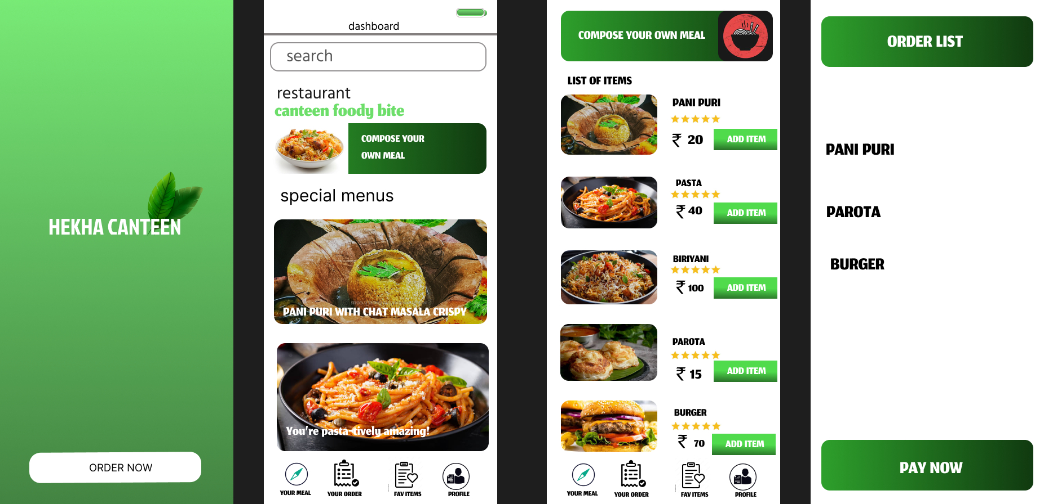

**Procedure:**

**Set Up the Figma File:**

* I created a new file in Figma and set up frames for key screens like the Home screen, Menu, Cart, and Order Confirmation.

**Define the Design System:**

* I chose a green color palette to give the app a fresh, vibrant feel, and selected complementary colors for buttons, backgrounds, and text.
* I set up typography styles for headings, subheadings, and body text for consistency.

**Design UI Elements:**

* I created reusable UI components such as buttons, navigation bars, and cards for displaying menu items, using the green theme throughout.

**Build the Screens:**

* I designed the Home screen with quick access to the menu and order buttons. The Menu screen displayed food items with an "Add to Cart" feature.
* The Cart and Order Confirmation screens allowed users to review their order and confirm payment.

**Add Prototyping and Interactions:**

* I linked screens to create a seamless flow between actions, such as adding an item to the cart and navigating to checkout.

### **Result:**

A functional, visually appealing canteen app with a green theme, offering an intuitive user interface for browsing the menu, placing orders, and reviewing purchase details. The app is designed for ease of use, with consistent colors, fonts, and intuitive interactions.